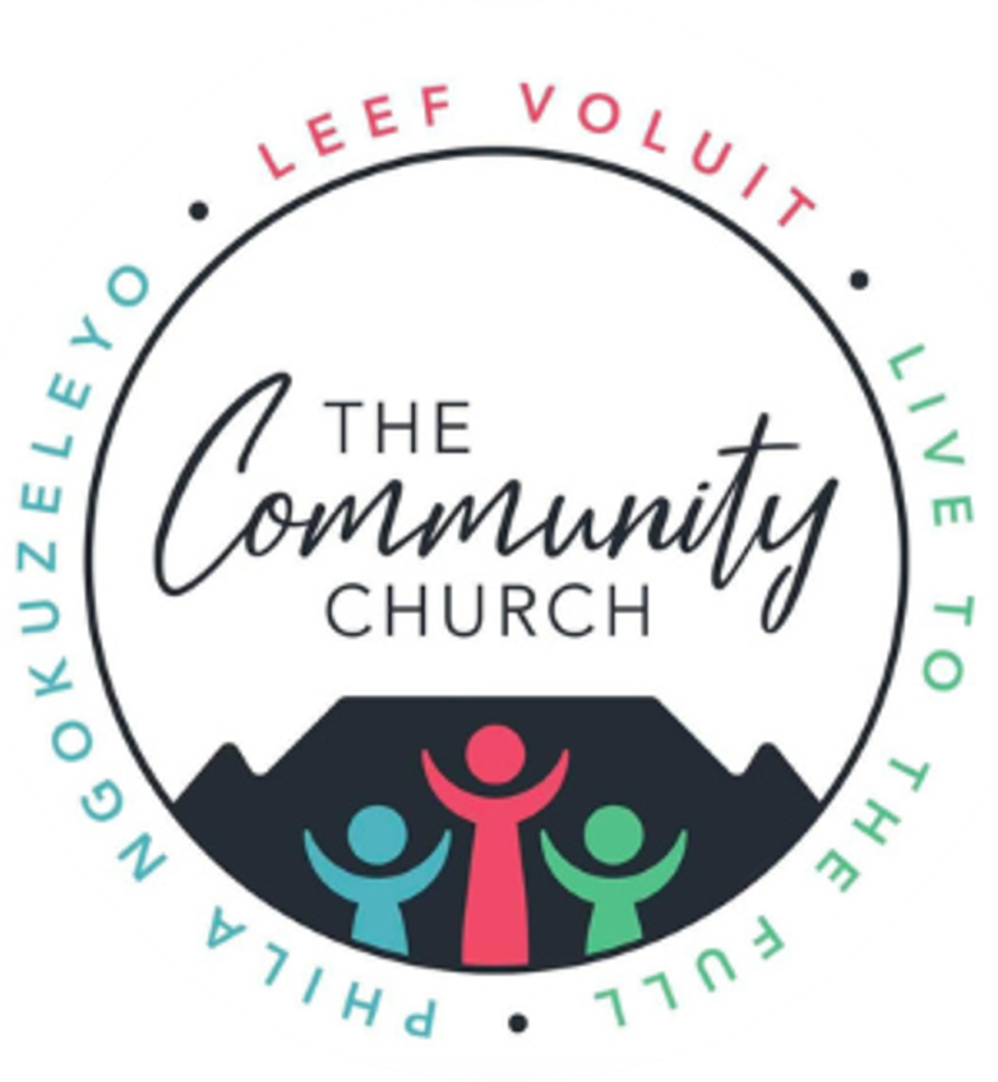
Baptism Application Form
Community Church, 58 Braselton Road, Cape Town
At Community Church, we view baptism as a sacred step in your faith journey, reflecting a commitment to follow Christ with compassion and love, as guided by Scripture. Please complete this form to apply for baptism. Our pastoral team will contact you to discuss the next steps, including baptism preparation.
Applicant Information
Full Name: _______________________________
Date of Birth: ____________________________
Contact Number: __________________________
Email Address: ___________________________
Residential Address: ______________________
Spiritual Background
- Why do you seek baptism? (Please share your reasons or personal faith journey in a few sentences.)
- Have you been baptized before? (If yes, please provide details, including when and where.)
- Are you currently attending Community Church?
  - Yes, regularly
  - Yes, occasionally
  - No (If no, please share how you learned about our church.)
Preparation and Commitment
Baptism at Community Church involves a preparation process to deepen your understanding of this sacred commitment.
- Are you willing to participate in baptism preparation sessions?
  - Yes
  - No (Please explain: ___________________________)
- Preferred Baptism Date (if known): _________________________
Additional Information
Any additional comments or questions for the pastoral team?
Scriptural Foundation:
As a community rooted in Christ’s love, we are inspired by Mark 16:16 (KJV):
"Whoever believeth and is baptized shall be saved; but whoever believeth not shall be damned."
This verse reminds us of the importance of faith and baptism in our walk with Christ.
Submission Instructions:
Please submit this form to the church office at 58 Braselton Road, Cape Town, or email it to [insert church email]. For inquiries, contact Pastor Willem Pretorius at [insert contact number].
Signature: _______________________________
Date: _______________________________

