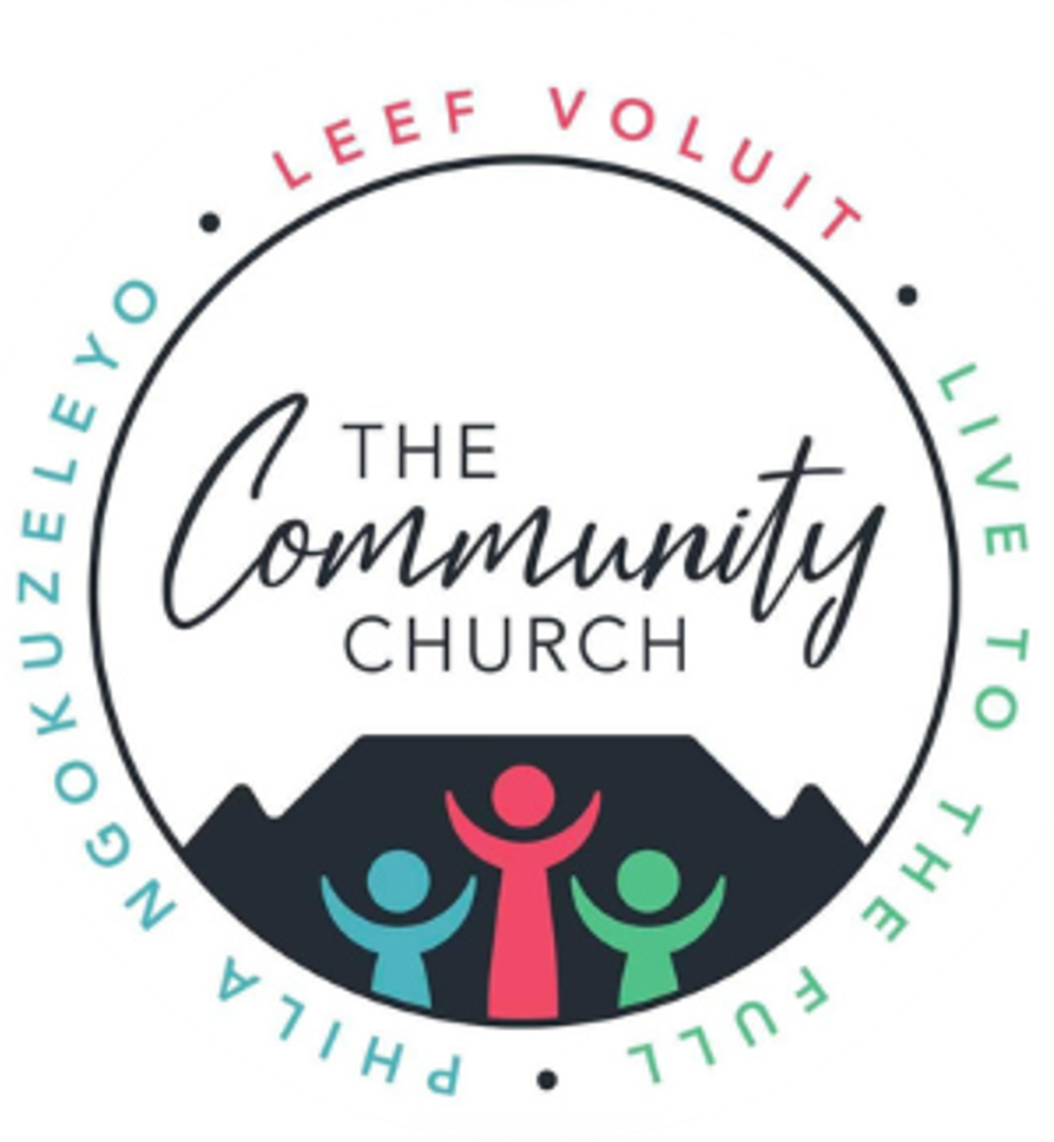
Funeral Application Form
Community Church, 58 Braselton Road, Cape Town
At Community Church, we seek to honor the life of the departed and support families with Christ’s compassion and love, guided by Scripture. Please complete this form to arrange a funeral service. Pastor Willem Pretorius will contact you to discuss details and provide pastoral care.
Applicant Information
Person arranging the funeral
- Full Name and Surname: _______________________________
- Relationship to Deceased: ___________________________
- Cellphone Number: ________________________
- Email Address: ___________________________
- Residential Address: ______________________
Funeral Service Details
- Preferred Date of Service: ___________________
- Preferred Time: __________________________
- Venue Preference:
  - Community Church Sanctuary
  - Other (Please specify: ___________________)
- Estimated Number of Attendees: _______________
- Food requirements: Sandwiches coffee and tea and juice _______________
Special Requests
Please specify any preferences for the service:
- Microphones:
  - Required (Specify number: _____)
  - Not required
- Sound Technician:
  - Required for audio setup and management
  - Not required
- Video Recording/Streaming:
  - Video recording only
  - Live streaming (Specify platform, if preferred: _______________)
  - Both recording and streaming
  - Not required
- Other Requests: (E.g., specific music/songs, readings, eulogists, or memorial elements)
___________________________________________________________________________
___________________________________________________________________________
___________________________________________________________________________
Details of the Funeral home providing the service
Name of Instituion:______________________________________
Contact Details: ______________________________________
Type of service
Memorial service
Time:
Date:
Place:
Cremation
details
Time:
Date:
Place:
Burial:
Time:
Date:
Place:
Deceased’s Information
Required for Department of Home Affairs death registration, where applicable
- Full Name and Surname: _________________________________________________
- ID Number (or Passport Number for non-residents): ___________________________
Flowers or bouquets needed (please give specifications)

- Any specific spiritual or pastoral needs for the service? (E.g., particular scriptures, prayers, or counseling support.)
___________________________________________________________________________________________________________________________________________________________________________________________________________________________________________________________________________________________________________________________
Scriptural Foundation
Our approach to funerals is inspired by John 11:25-26 (KJV):
"Jesus said unto her, I am the resurrection, and the life: he that believeth in me, though he were dead, yet shall he live: And whosoever liveth and believeth in me shall never die."
This verse offers hope and comfort, reflecting Christ’s promise of eternal life.
Submission Instructions:
Submit this form and required documents to the church office at 58 Braselton Road, Cape Town, or email to admin@communitychurch.co.za. For inquiries, contact Estelle Van Coller at 073 890 5999.
Signature of Applicant: _______________________________
Date: _______________________________

