﻿
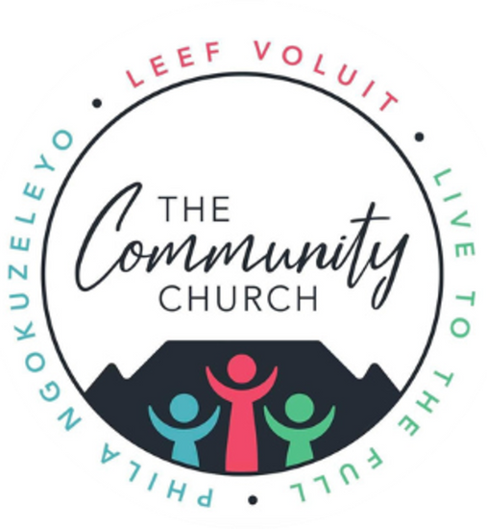

﻿Wedding Application Form
Community Church, 58 Braselton Road, Cape Town
At Community Church, we celebrate marriage as a sacred covenant rooted in Christ’s love and guided by Scripture. Please complete this form to apply for your wedding. Pastor Willem Pretorius, our marriage officer, will contact you to discuss preparation and next steps.
Couple’s Information
Required by the Department of Home Affairs
Partner 1
- Full Name and Surname: _______________________________
- ID Number (or Passport Number for non-residents): _________
- Date of Birth: ____________________________
- Nationality: _____________________________
- Country of Birth: _________________________
- City of Birth: ____________________________
- Cellphone Number: ________________________
- Email Address: ___________________________
- Current Residential Address: _______________
- Current Occupation: _______________________
- Highest Qualification: ____________________
- Marital Status:
  - Single (Never married)
  - Divorced
  - Widowed
Partner 2
- Full Name and Surname: _______________________________
- ID Number (or Passport Number for non-residents): _________
- Date of Birth: ____________________________
- Nationality: _____________________________
- Country of Birth: _________________________
- City of Birth: ____________________________
- Cellphone Number: ________________________
- Email Address: ___________________________
- Current Residential Address: _______________
- Current Occupation: _______________________
- Highest Qualification: ____________________
- Marital Status:
  - Single (Never married)
  - Divorced
  - Widowed
Marriage Details
- Present Surname (Partner 1): _______________
- Maiden Surname (if applicable): ____________
- Surname After Marriage: ___________________
- Proposed Date of Marriage: _________________
- Place of Marriage: ________________________
Witnesses
Both witnesses must be present at the ceremony and provide valid identification.
Witness 1
- Full Name and Surname: _______________________________
- ID Number (or Passport Number): ______________________
- Place of Marriage: ________________________
- Cellphone Number: ________________________
Witness 2
- Full Name and Surname: _______________________________
- ID Number (or Passport Number): ______________________
- Place of Marriage: ________________________
- Cellphone Number: ________________________
Wedding Preferences
- Preferred Wedding Date: ___________________
- Preferred Time: __________________________
- Venue Preference:
  - Community Church Sanctuary
  - Other (Please specify: ___________________)

Department of Home Affairs Requirements
To register your marriage with the Department of Home Affairs, please provide:
- Three color ID photos (passport-size) of each partner.
- Certified copies (not older than three months) of each partner’s South African ID or valid passport.
- Certified copies (not older than three months) of IDs or passports for two witnesses (must have valid South African IDs or passports).
- If applicable:
  - Proof of antenuptial agreement (letter from attorney stating full names, ID/passport numbers, and agreement details).
  - Final divorce decree or court order (if previously married).
  - Death certificate of previous spouse (if widowed).
  - For non-residents or foreign nationals:
    - Valid passport and visa or proof of legal status in South Africa (e.g., permanent residence permit).
    - A letter of no impediment from the home country’s embassy or consulate, confirming freedom to marry (if required by DHA).
Note: All documents must be in English or accompanied by a sworn translation. Incomplete documentation may delay marriage registration.
Spiritual and Relational Background
- Are you currently members or attendees of Community Church?
  - Yes, regularly
  - Yes, occasionally
  - No (If no, how did you learn about our church? ___________________________)

Preparation and Commitment
Marriage at Community Church requires premarital counseling to prepare for a Christ-centered union.
- Are you willing to participate in premarital counseling with Pastor Willem Pretorius?
  - Yes
  - No (Please explain: ___________________________)
Additional Information
Special requests or questions for the pastoral team? (E.g., music, officiant preferences, or logistical needs.)
Scriptural Foundation:
Our approach to marriage is inspired by Ephesians 5:25 (KJV):
"Husbands, love your wives, even as Christ also loved the church, and gave himself for it."
This verse reflects the sacrificial, compassionate love at the heart of Christian marriage.
Submission Instructions:
Submit this form and required documents to the church office at 58 Braselton Road, Cape Town, or email to admin@communitychurch.co.za. For inquiries, contact Estelle Van Coller at 073 890 5999.
Signatures:
Partner 1: _______________________________ Date: _____________
Partner 2: _______________________________ Date: _____________

